**Database connectivity in PHP (CRUD operation)**

**Lab report #07**



Spring 2023

CSE-423L Web Engineering

Submitted by: **Ashfaq Ahmad**

Registration No: **19PWCSE1795**

Class Section: **B**

“On my honor, as student of University of Engineering and Technology, I have neither given nor received unauthorized assistance on this academic work.”

Student Signature: ______________

Submitted to:

**Eng. Usman Malik**

**June** 09, 2023

**Department of Computer Systems Engineering**

**University of Engineering and Technology, Peshawar**

**Task 01:**

Create a database “school”, make a database connection, write PHP code to insert data from

the form below into MySQL database.

**PHP Code:**

<!DOCTYPE html>

<html lang="en">

<head>

    <meta charset="UTF-8">

    <meta name="viewport" content="width=device-width, initial-scale=1.0">

    <title>Document</title>

    <style>

        .container{

*width*: 400px;

*margin*: 20px auto;

        }

        td,th{

*background-color*: #d0d0d0;

*width*: 180px;

*height*: 30px;

        }

        caption{

*background-color*: yellow;

*height*: 30px;

        }

        th{

*display*: flex;

*flex-direction*: column;

*text-align*: end;

*justify-content*: center;

        }

        #insertbtn{

*background-color*: green;

*color*: white;

*width*: 100px;

*height*: 30px;

        }

    </style>

</head>

<body>

    <div class='container'>

    <form action="<?php echo $_SERVER['PHP_SELF']; ?>" method="post">

        <table cellspacing="5">

            <caption><b>Student's Registration Form</b></caption>

            <tr>

                <th>Student's Name</th>

                <td><input type="text" name="studentname"></td>

            </tr>

            <tr>

                <th>Father's Name</th>

                <td><input type="text" name="fathername"></td>

            </tr>

            <tr>

                <th>School's Name</th>

                <td><input type="text" name="schoolname"></td>

            </tr>

            <tr>

                <th>Roll No</th>

                <td><input type="text" name="rollno"></td>

            </tr>

            <tr>

                <th>Class</th>

                <td><input type="text" name="class"></td>

            </tr>

        </table>

        <div style="text-align: center;">

                <input type="submit" name="submit" value="Insert Data" id="insertbtn">

        </div>

    </form>

    <?php

        if(isset($_POST['submit'])){

        $studentname=$_POST['studentname'];

        $fathername=$_POST['fathername'];

        $schoolname=$_POST['schoolname'];

        $rollno=$_POST['rollno'];

        $class=$_POST['class'];

        $connect=new *mysqli*('localhost','root','12345','school');

        if(!$connect){

            die('Connection failed: '. mysqli_connect_error());

        }

        $db_selected=mysqli_select_db($connect,'school');

        if(!$db_selected){

            die('Database can\'t be selected:' . mysql_error($connect));

        }

        $sql="insert into registration (studentname,fathername,schoolname,rollno,class) values ('$studentname','$fathername','$schoolname','$rollno','$class')";

        if(mysqli_query($connect,$sql)){

            echo "<script>alert('Data is Inserted to database Successfully.') </script>";

        } else {

            echo 'Error: '. mysql_error($connect);

        }

        mysqli_close($connect);

    }

    ?>

    </div>

</body>

</html>

**Result:**

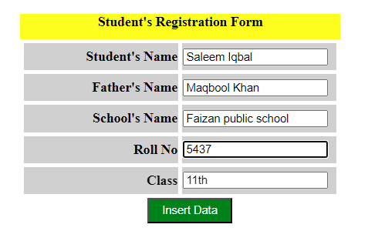

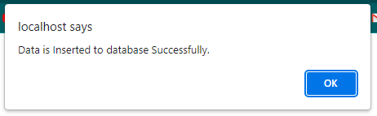

**Database:**

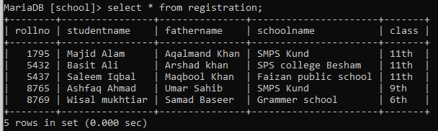

**Task 02:**

For this task retrieve all the records from the database school, and show on the web page in

table format. Add two more columns to the table; one for editing and one for deleting the

record.

When the user clicks on Delete/Edit it deletes/edits that particular record and displays a

message that the record has been deleted/edited successfully.

**Connection.php:**

<?php

    $connect=new *mysqli*('localhost','root','12345','school');

    if(!$connect){

        die('Connection failed: '. mysqli_connect_error());

    }

    $db_selected=mysqli_select_db($connect,'school');

    if(!$db_selected){

        die('Database can\'t be selected:' . mysql_error($connect));

    }

    $sql="select * from registration";

    $rows=mysqli_query($connect,$sql);

?>

**fetch.php:**

<!DOCTYPE html>

<html lang="en">

<head>

    <meta charset="UTF-8">

    <meta name="viewport" content="width=device-width, initial-scale=1.0">

    <title>Document</title>

    <style>

        .container{

*margin*: 20px 180px;

        }

        table{

*table-layout*: auto;

*text-align*: center;

*border-spacing*: 5px;

*align*: center;

        }

        #editbtn{

*background-color*: green;

*color*: white;

*width*: 100px;

*height*: 30px;

        }

        #deletebtn{

*background-color*: red;

*color*: white;

*width*: 100px;

*height*: 30px;

        }

    </style>

</head>

<body>

    <div class='container'>

    <form action="<?php echo $_SERVER['PHP_SELF']; ?>" method="post">

        <table border='1'>

            <tr style='background-color: yellow;'>

                <th colspan='8' height="50px">View All Records</th>

            </tr>

            <tr>

                <th>Serial No</th>

                <th>Student's Name</th>

                <th>Father's Name</th>

                <th>School's Name</th>

                <th>Roll No</th>

                <th>Class</th>

                <th colspan='2'>Operations</th>

            </tr>

        <?php

        include('connection2.php');

        if($rows->num_rows>0){

        $count=0;

         while ($row= $rows -> fetch_assoc()){

            $count= $count +1;

            echo '

                <tr>

                    <td>'. $count.'</td>

                    <td>'.$row['studentname'].'</td>

                    <td>'.$row['fathername'].'</td>

                    <td>'.$row['schoolname'].'</td>

                    <td>'.$row['rollno'].'</td>

                    <td>'.$row['class'].'</td>

                    <td><a href=\'delete2.php?rn='.$row['rollno'].'\'><input type=\'button\' value=\'Delete\' id=\'deletebtn\'></a></td>

                    <td><a href=\'update2.php?sn='.$row['studentname'].'&fn='.$row['fathername'].'&scln='.$row['schoolname'].'&rn='.$row['rollno'].'&cls='.$row['class'].'\'><input type=\'button\' value=\'Update\' id=\'editbtn\'></a></td>

                </tr>';

         }

         ?>

        </table>

    </form>

    <?php

            echo '<br><b><font color="green">Data Fetched from database Successfully...</font><b>';

        }

        else {

            echo '<font color="red">Database is Empty.</font> <br>';

        }

        ?>

    </div>

</body>

</html>

**update.php:**

<?php

include('connection2.php');

error_reporting(0);

$sn = $_GET['sn'];

$fn = $_GET['fn'];

$scln = $_GET['scln'];

$rn = $_GET['rn'];

$cls = $_GET['cls'];

?>

<!DOCTYPE html>

<html lang="en">

<head>

    <meta charset="UTF-8">

    <meta name="viewport" content="width=device-width, initial-scale=1.0">

    <title>Document</title>

    <style>

        .container{

*width*: 400px;

*margin*: 20px auto;

        }

        td,th{

*background-color*: #d0d0d0;

*width*: 180px;

*height*: 30px;

        }

        caption{

*background-color*: yellow;

*height*: 30px;

        }

        th{

*display*: flex;

*flex-direction*: column;

*text-align*: end;

*justify-content*: center;

        }

        #updatebtn{

*background-color*: green;

*color*: white;

*width*: 100px;

*height*: 30px;

        }

    </style>

</head>

<body>

    <div class='container'>

    <form action="" method='GET'>

        <table cellspacing="5">

            <caption><b>Student's Registration Form</b></caption>

            <tr>

                <th>Student's Name</th>

                <td><input type="text" name="studentname" value="<?php echo $sn ?>"></td>

            </tr>

            <tr>

                <th>Father's Name</th>

                <td><input type="text" name="fathername" value="<?php echo $fn?>"></td>

            </tr>

            <tr>

                <th>School's Name</th>

                <td><input type="text" name="schoolname" value="<?php echo $scln?>"></td>

            </tr>

            <tr>

                <th>Roll No</th>

                <td><input type="text" name="rollno" value="<?php echo $rn?>"></td>

            </tr>

            <tr>

                <th>Class</th>

                <td><input type="text" name="class"  value="<?php echo $cls?>"></td>

            </tr>

        </table>

        <div style="text-align: center;">

                <input type="submit" name="submit" value="Update Form" id="updatebtn">

        </div>

    </form>

    </div>

</body>

</html>

<?php

if (isset($_GET['submit'])) {

    $studentname = $_GET['studentname'];

    $fathername = $_GET['fathername'];

    $schoolname = $_GET['schoolname'];

    $rollno = $_GET['rollno'];

    $class = $_GET['class'];

    $query2= "update registration set studentname='$studentname',fathername='$fathername',schoolname='$schoolname',class='$class' where rollno='$rollno' ";

    if(mysqli_query($connect,$query2)){

        echo "<script>alert('Record having id=" .$rollno." is updated Successfully.') </script>";

    ?>

    <meta http-equiv="refresh" content="0; url=http://localhost/lab07/fetch.php">

    <?php

    } else {

        echo '<font color="red">Failed to update Record.</font><br>';

        echo 'Error: '. mysql_error($connect);

    }

}

?>

**delete.php:**

<?php

include('connection2.php');

$rn = $_GET['rn'];

$query1 = "DELETE FROM registration WHERE rollno='$rn'";

$deleted = mysqli_query($connect, $query1);

if ($deleted) {

    echo "<script>alert('Record having Roll No = " .$rn." is deleted Successfully.') </script>";

    ?>

    <meta http-equiv="refresh" content="0; url=http://localhost/lab07/fetch.php">

<?php

} else {

        echo '<font color="red">Failed to Delete Record.</font><br>';

        echo 'Error: '. mysql_error($connect);

}

?>

**Result:**

**Fetch Data:**

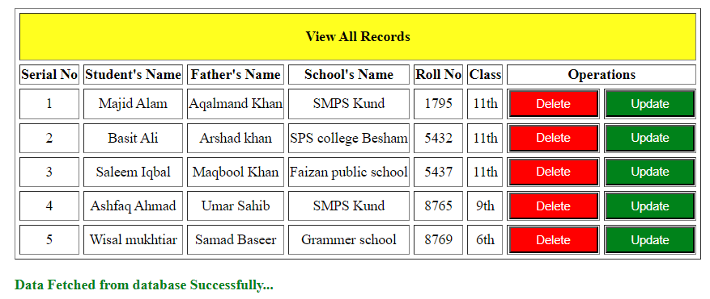

**Delete Data:**

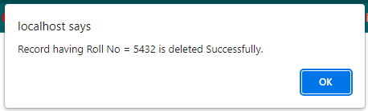

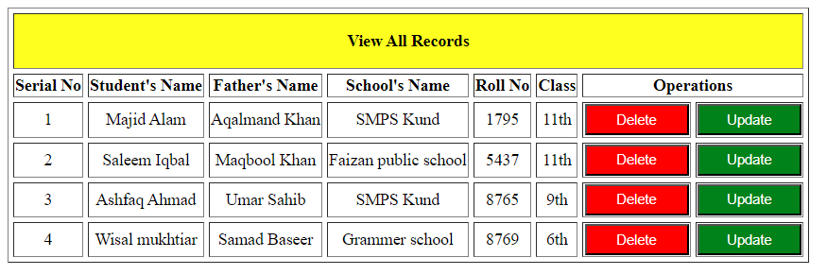

**Update Data:**

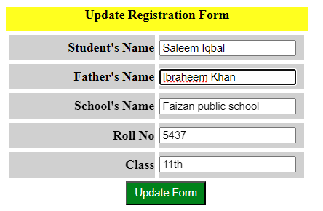

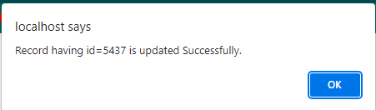

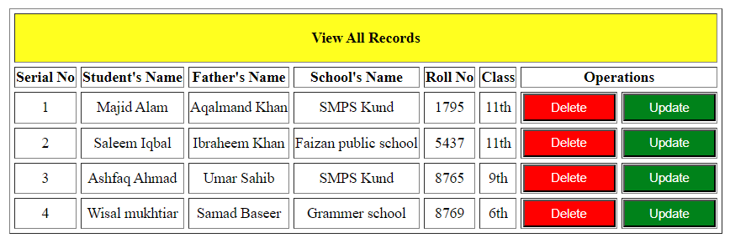

**Task 03:**

Create a basic social networking website called CONNECTIONS using PHP and MySQL

database. It should have the following functionality:

• Users can register themselves

• Only registered users can login

• After login, users can send a text message to anybody who is registered with the

website

• Users can view the received messages

**Home Page:**

<!DOCTYPE html>

<html>

<head>

  <title>Home Page</title>

  <style>

    body {

*background-color*: #f2f2f2;

*font-family*: Arial, sans-serif;

*margin*: 0;

*padding*: 0;

    }

    .header {

*position*: fixed;

*top*: 0;

*left*: 0;

*width*: 100%;

*height*: 60px;

*background-color*: rgb(77, 69, 77);

*color*: white;

*box-shadow*: 0 0 10px rgba(0, 0, 0, 0.1);

*display*: flex;

*justify-content*: space-between;

*align-items*: center;

*padding*: 0px 20px;

*box-sizing*: border-box;

    }

    .nav-links {

*display*: flex;

*justify-content*: flex-end;

*align-items*: center;

*gap*: 20px;

    }

    .nav-links a {

*text-decoration*: none;

*color*: white;

    }

    .nav-links a:hover {

*color*: blue;

    }

    .container {

*display*: flex;

*justify-content*: center;

*align-items*: center;

*height*: 100vh;

    }

    .form-card {

*width*: 300px;

*padding*: 40px;

*background-color*: #fff;

*border-radius*: 10px;

*box-shadow*: 0 0 10px rgba(0, 0, 0, 0.1);

    }

    h1 {

*text-align*: center;

*color*: #333;

    }

    .form-group {

*margin-bottom*: 20px;

    }

    .form-group label {

*display*: block;

*margin-bottom*: 5px;

*font-weight*: bold;

*color*: #555;

    }

    .form-group input[type="text"],

    .form-group input[type="password"],

    .form-group input[type="email"] {

*width*: 100%;

*padding*: 10px;

*border*: none;

*border-radius*: 5px;

*background-color*: #f2f2f2;

    }

    .form-group input[type="submit"] {

*width*: 100%;

*padding*: 10px;

*border*: none;

*border-radius*: 5px;

*background-color*: #4CAF50;

*color*: #fff;

*cursor*: pointer;

    }

    .form-group input[type="submit"]:hover {

*background-color*: #45a049;

    }

    .form-switch {

*text-align*: center;

*margin-top*: 20px;

    }

    .form-switch a {

*color*: blue;

*text-decoration*: none;

    }

    .footer {

*text-align*: center;

*padding*: 30px;

*background-color*: black;

*color*:white;

*box-shadow*: 0 0 10px rgba(0, 0, 0, 0.1);

    }

  </style>

</head>

<body>

<div class="header">

    <div class="logo"><img src=""></div>

    <div class="nav-links">

      <a href="#">Home</a>

      <a href="#">About</a>

    </div>

</div>

  <br><br>

  <div class="container">

    <div class="form-card">

      <h1>Welcome!</h1>

      <form id="login-form">

        <h2>Login</h2>

        <div class="form-group">

          <label for="login-username">Username</label>

          <input type="text" id="login-username" placeholder="Enter your username" required>

        </div>

        <div class="form-group">

          <label for="login-password">Password</label>

          <input type="password" id="login-password" placeholder="Enter your password" required>

        </div>

        <div class="form-group">

          <input type="submit" value="Login">

        </div>

        <div class="form-switch">

          Don't have an account? <a href="#signup-form">Sign up</a>

        </div>

      </form>

      <form id="signup-form" style="display: none;">

        <h2>Sign Up</h2>

        <div class="form-group">

          <label for="signup-username">Username</label>

          <input type="text" id="signup-username" placeholder="Choose a username" required>

        </div>

        <div class="form-group">

          <label for="signup-email">Email</label>

          <input type="email" id="signup-email" placeholder="Enter your email address" required>

        </div>

        <div class="form-group">

          <label for="signup-password">Password</label>

          <input type="password" id="signup-password" placeholder="Choose a password" required>

        </div>

        <div class="form-group">

          <input type="submit" value="Sign Up">

        </div>

        <div class="form-switch">

          Already have an account? <a href="#login-form">Login</a>

        </div>

      </form>

    </div>

  </div>

  <div class="footer">

      &copy; 2023 My Website. All rights reserved.

    </div>

  <script>

    // Form switch functionality

*const* loginForm = document.getElementById('login-form');

*const* signupForm = document.getElementById('signup-form');

*const* formSwitchLinks = document.querySelectorAll('.form-switch a');

    formSwitchLinks.forEach(*link* *=>* {

      link.addEventListener('click', (*e*) *=>* {

        e.preventDefault();

        loginForm.style.display = (loginForm.style.display === 'none') ? 'block' : 'none';

        signupForm.style.display = (signupForm.style.display === 'none') ? 'block' : 'none';

      });

    });

  </script>

</body>

</html>

**UserInfo.php:**

<!DOCTYPE html>

<html>

<head>

  <title>User Dashboard</title>

  <style>

    /* CSS styles for the page layout */

    body {

*background-color*: #f2f2f2;

*font-family*: Arial, sans-serif;

*margin*: 0;

*padding*: 0;

    }

    .container {

*display*: flex;

*justify-content*: center;

*align-items*: center;

*height*: 100vh;

    }

    .dashboard {

*background-color*: #fff;

*padding*: 20px;

*border-radius*: 10px;

*box-shadow*: 0 0 10px rgba(0, 0, 0, 0.1);

*max-width*: 400px;

*width*: 100%;

    }

    .user-info {

*text-align*: center;

*margin-bottom*: 20px;

    }

    .user-info h2 {

*margin*: 0;

    }

    .actions {

*display*: flex;

*flex-direction*: column;

*gap*: 10px;

    }

    .action-btn {

*padding*: 10px;

*background-color*: #4CAF50;

*color*: #fff;

*border*: none;

*border-radius*: 5px;

*cursor*: pointer;

    }

    .action-btn:hover {

*background-color*: #45a049;

    }

    .form-container {

*display*: none;

*margin-top*: 20px;

*background-color*: #f2f2f2;

*padding*: 10px;

*border-radius*: 5px;

    }

    .form-container.active {

*display*: block;

    }

    .form-container form {

*display*: flex;

*flex-direction*: column;

*gap*: 10px;

    }

    .form-container input[type="text"],

    .form-container textarea {

*padding*: 5px;

    }

    .form-container input[type="submit"] {

*padding*: 10px;

*background-color*: #4CAF50;

*color*: #fff;

*border*: none;

*border-radius*: 5px;

*cursor*: pointer;

    }

    .form-container input[type="submit"]:hover {

*background-color*: #45a049;

    }

  </style>

</head>

<body>

  <div class="container">

    <div class="dashboard">

      <div class="user-info">

        <h2>Welcome, John Doe!</h2>

        <p>User ID: 12345</p>

      </div>

      <div class="actions">

        <button class="action-btn" onclick="toggleForm('send-message')">Send Message</button>

        <button class="action-btn" onclick="toggleForm('inbox')">Inbox</button>

        <button class="action-btn" onclick="toggleForm('outbox')">Outbox</button>

        <button class="action-btn" onclick="toggleForm('sign-out')">Sign Out</button>

      </div>

      <div class="form-container" id="send-message-form">

        <form>

          <h3>Send Message</h3>

          <input type="text" placeholder="Recipient" required>

          <textarea placeholder="Message" rows="4" required></textarea>

          <input type="submit" value="Send">

        </form>

      </div>

      <div class="form-container" id="inbox-form">

        <form>

          <h3>Inbox</h3>

          <!-- Add inbox form fields here -->

          <input type="submit" value="Submit">

        </form>

      </div>

      <div class="form-container" id="outbox-form">

        <form>

          <h3>Outbox</h3>

          <!-- Add outbox form fields here -->

          <input type="submit" value="Submit">

        </form>

      </div>

      <div class="form-container" id="sign-out-form">

        <form>

          <h3>Sign Out</h3>

          <!-- Add sign out form fields here -->

          <input type="submit" value="Submit">

        </form>

      </div>

    </div>

  </div>

  <script>

*function* toggleForm(*formId*) {

*const* formContainer = document.getElementById(formId + '-form');

      formContainer.classList.toggle('active');

    }

  </script>

</body>

</html>

**Result:**

